ZIDIO DATA SCIENCE & ANALYTICS INTERNSHIP
PROJECT FORESIGHT
AI-Powered Demand Forecasting & Inventory Risk Intelligence for Multi-Store Retail

Internship Project Report
Submitted By
Rishikesh Ojha • Swapnil Shirude • Ashika Keshri • Sreedhar Naidu
Project Duration: 4 Weeks
Domain: Retail Analytics | Track: Data Science & Machine Learning
Organization: Zidio

Table of Contents
1. Project Overview
2. Architecture & Workflow
3. Execution Timeline
4. Data Understanding & Data Quality
5. Exploratory Data Analysis
6. Feature Engineering & Demand Forecasting
7. Stockout & Overstock Risk Scoring
8. Business Impact - Quantifying the Rupee Value
9. Interactive Dashboard
10. Technology Stack & Key Features
11. Recommended Actions
12. Limitations, Stated Plainly
13. Challenges Faced & Solutions
14. Key Learnings
15. Future Roadmap
16. Conclusion

1. Project Overview
Project FORESIGHT is an end-to-end data science project built during the Zidio Data Science & Analytics internship. It analyses a 10-million-transaction, multi-store retail dataset to detect and quantify two opposite inventory problems in the same business: stockouts on fast-selling products (lost, unrecoverable revenue) and overstock on slow-moving products (cash tied up in unsold stock). The project delivers a validated weekly demand-forecasting model, a rule-based risk-scoring engine, and an interactive web dashboard for the operations and finance teams.

1.1 Vision & Objectives
- Forecast weekly, SKU-level product demand using historical sales, seasonal patterns, and category signals.
- Detect products at risk of stocking out before the shelf actually goes empty.
- Detect slow-moving products tying up working capital in excess inventory.
- Quantify the rupee impact of both problems using the project's own verified ground truth, not assumptions.
- Deliver an operations-ready dashboard with a prioritised, actionable SKU list - not just charts.

1.2 Target Users / Use Cases
- Retail store & category managers deciding what to reorder or mark down
- Supply chain / inventory planning teams setting safety stock and reorder points
- Finance teams tracking capital tied up in inventory
- Business analysts and leadership reviewing company-wide performance

1.3 Business Value Delivered
- A forecasting model that beats a naive seasonal baseline by 9.9%–24.7% across three independent backtest periods
- A prioritised reorder list (396 SKUs) and markdown/clearance list (707 SKUs) ready for action
- A precise, defensible rupee figure for money already lost (Rs. 3.23 crore) versus money still recoverable (Rs. 79.9 crore)
- Single-SKU-level accountability: the one product responsible for a third of all stockout losses is identified by name

1.4 Non-Functional Goals
- Scalable pipeline: ~9.95 million raw transaction rows processed in fixed-memory batches, not loaded all at once
- Reproducible evaluation: walk-forward backtesting on time periods the model never trained on, not a random train/test split
- Every headline number traceable to a verified calculation, not an estimate — documented at each step
- Modular pipeline: data quality → EDA → feature engineering → forecasting → risk scoring → dashboard, each stage saved as reusable Parquet output

2. Architecture & Workflow
The project follows an end-to-end analytics pipeline, moving from raw transactional data to a decision-ready dashboard:
Raw Sales Data → Data Cleaning & Profiling → EDA → Feature Engineering → Demand Forecasting (LightGBM) → Risk Scoring → Interactive Dashboard → Executive Reporting

2.1 Project Phases
Phase | Deliverable
1. Business Understanding | Problem framing: stockout loss vs. overstock capital lock-up
2. Data Collection & Engineering | Raw CSV ingestion, chunked aggregation, Parquet pipeline
3. Exploratory Data Analysis | Revenue trends, seasonality, Pareto analysis, promotion testing
4. Feature Engineering | Weekly grid, lag features, rolling statistics, calendar features
5. Demand Forecasting | LightGBM model, walk-forward backtesting vs. seasonal-naive baseline
6. Risk Scoring | Stockout / overstock classification, threshold tuning against ground truth
7. Dashboard Development | 7-page interactive web dashboard for operations & finance
8. Deployment & Documentation | Data Quality Report, EDA Memo, Executive Readout

2.2 Data Sources
Synthetic multi-store retail dataset sourced via Kaggle (10 million transactions), representing a Pakistan-based retail chain: 30 stores across Karachi, Islamabad, Quetta, Multan, and Sialkot; 5,000 SKUs; 10,000 customers; covering 2022–2025. All monetary figures are reported in Rs. (PKR), matching the store locations.
The dataset ships in two parallel folders: a contaminated version with injected stockout and overstock anomalies (treated as the client's real, current data), and a clean reference version with no injected anomalies, held back and used only later to calculate the exact rupee value of sales lost to those anomalies.

3. Execution Timeline
Week | Focus | Key Activities
Week 1 | Data Understanding & Preparation | Dataset profiling, referential-integrity checks, resolving the duplicated flags-file conflict, stockout-censoring detection, chunked pipeline build
Week 2 | Data Analysis & Core Dashboards | Revenue trend & CAGR analysis, seasonality, Pareto/SKU concentration, promotion-effectiveness testing, category economics
Week 3 | Advanced Analytics | Weekly feature engineering (lags, rolling stats), seasonal-naive baseline, LightGBM forecasting model, walk-forward backtesting, risk-scoring engine & threshold tuning
Week 4 | Executive Insights & Finalization | Interactive dashboard build (7 pages), rupee-impact quantification, Executive Readout, recommendations, final documentation

4. Data Understanding & Data Quality
Before any analysis, every table was profiled directly against the raw data rather than trusting the dataset's own documentation.

4.1 Table Profile
Table | Rows | Columns | Missing Values | Duplicate Rows
store_master.csv | 30 | 5 | 0 | 0
sku_master.csv | 5,000 | 7 | 0 | 0
customer_master.csv | 10,000 | 7 | 0 | 0
promotions.csv | 100 | 8 | 0 | 0
inventory_snapshot.csv | 26,408 | 6 | 0 | 0
sku_inventory_flags.csv | 600 | 6 | 0 | 0
sales_transactions.csv | ~9,945,511 | 11 | None found (sampled/aggregated views) | Not checked row-by-row at this scale
Referential integrity: 0 SKUs and 0 stores in inventory_snapshot.csv were missing from their respective master tables - no orphaned foreign keys.

4.2 Data-Quality Issues Found & Resolved

Issue 1 - inventory_snapshot.csv row count vs. documentation
Documented as ~21,228 rows; the actual file loaded contains 26,408 rows. No corruption was found (zero missing values, zero duplicates, zero orphaned keys) - this was treated as a documentation discrepancy, not a data defect, and the actual loaded data was used.

Issue 2 - sku_inventory_flags.csv differs between the clean and contaminated dataset folders
This ground-truth answer key exists in both dataset folders with the same row count (600) but different content - even after sorting by SKU ID, all 600 rows differ. This pointed to two separate generation runs rather than one file copied by mistake.
Resolution: the contaminated folder's flags file was adopted as the single authoritative source, since a flags file inside the clean folder cannot describe anomalies in a sales file that has none by definition. This was verified directly: for the first STOCKOUT_RISK row (SKU04321, store ST22, 2025-11-06 to 2025-12-03), a full scan of all ~9.95M transaction rows confirmed zero matching sales in that exact window - consistent with the documented injection method.

Issue 3 -Censored demand during stockout windows
Exploding all 200 STOCKOUT_RISK rows across their affected stores and date windows identified 55,327 exact (date, store, SKU) combinations where sales were suppressed to zero by an injected stockout - not by genuine absence of demand. Each of these was explicitly flagged with an stockout censored indicator in the processed pipeline, so downstream modeling does not learn "demand = 0" when the correct read is "the shelf was empty."

4.3 Known Limitation - Holiday Calendar
The derived calendar dimension flags fixed-date Pakistani public holidays (Kashmir Day, Pakistan Day, Labour Day, Independence Day, Iqbal Day, Quaid-e-Azam Day). Eid ul-Fitr and Eid ul-Adha follow the lunar Islamic calendar and shift every year, and are not included in the current holiday flag - documented here as a known limitation rather than an oversight discovered later.

4.4 Pipeline Output
The raw sales_transactions.csv (~9,945,511 rows) was streamed and aggregated in 1,000,000-row batches to stay within available memory, producing three analysis-ready Parquet tables:
- daily_store_sku_final.parquet - one row per (date, store, SKU), including the stockout censored flag plus SKU and store attributes
- daily_sku_final.parquet - one row per (date, SKU), summed across all 30 stores; the grain used for demand forecasting
- calendar.parquet - a 1,461-row date dimension (2022-01-01 to 2025-12-31) with week, month, quarter, day-of-week, weekend, season, and holiday flags
All aggregated prices (avg_unit_price, avg_discount_pct) were computed as revenue-weighted averages - total revenue ÷ total units - rather than an average of per-batch averages, which would silently understate the true figure when combining chunks.

4.5 Sign-Off
DATA QUALITY RESULT
0 missing · 0 duplicates · 0 orphaned keys
Across every table in the dataset - two genuine issues found were verified directly and explicitly handled, not silently ignored.

5. Exploratory Data Analysis
All figures below are computed from daily, sku final the chain-wide daily aggregate, using the contaminated (working) dataset. All monetary values are in Rs. (PKR).

5.1 Revenue Trend & the Growth-Rate Discrepancy
Compound annual growth rate, 2022 → 2025: 4.9% - measurably below the dataset documentation claimed ~6%/year. Year-over-year growth was 1.9% (2023), 2.0% (2024), then a jump to 11.0% (2025).
This was investigated rather than left as a curiosity: the injected stockout windows fall inside the last ~75 days of the dataset - i.e., inside 2025. Real customer demand in that period existed but was never recorded as a sale. This means the 4.9% CAGR understates the true underlying growth trend rather than contradicting the documentation; the exact rupee size of that gap is quantified in Section 8.

5.2 Seasonality
- Nov/Dec peak -confirmed cleanly, no exceptions: December is the single highest-revenue month in all 4 years; November is the second-highest in all 4 years.
- Feb trough -real but not universal: February is the lowest-revenue month in 2023 and 2025, but not in 2022 (June is, narrowly) or 2024 (March is).
- Seasonality is company-wide, not category-specific: measuring each category's peak-to-trough revenue swing gives a strikingly narrow range - every one of the 12 categories falls between 5.1 and 5.5 percentage points. Unlike many retailers, gift-type categories here do not swing harder around Nov/Dec than staples do.

5.3 Revenue Concentration & Top Movers
Sales follow a genuine Pareto skew: the top 20% of SKUs (1,000 of 5,000) generate 73.1% of total revenue.
SINGLE MOST IMPORTANT PRODUCT
SKU04321 — Rs. 1.069 Bn
Roughly 9.8% of total company revenue (Rs. 10.89 Bn) from one SKU out of 5,000 — and the same SKU independently confirmed in Week 1 to have a verified stockout window.

5.4 Risk-Flag Validation Against Actual Sales Rank
The dataset's own risk flags were checked directly against revenue and units percentile rank (0% = best-selling, 100% = worst-selling), rather than trusted at face value:
Flag | Avg. Revenue Percentile | Avg. Units Percentile
STOCKOUT_RISK | 11.6 | 2.0
SLOW_MOVER | 65.1 | 96.0
Unflagged | 50.4 | 48.0

STOCKOUT_RISK SKUs are extreme on both measures - genuine best-sellers. SLOW_MOVER SKUs are extreme only in units (96th percentile) but moderate in revenue (65th percentile): lower-volume items priced high enough that weak unit sales don't look alarming in pure revenue terms. Direct implication: overstock scoring must be built on units vs. stock on hand, not revenue.

5.5 Promotion Effectiveness
Two rounds of testing were needed to get an honest answer. A first test (each SKU's promo days vs. all its non-promo days, pooled across 4 years) showed weak, inconsistent lift -only 36.4% of SKUs showed any positive lift, because pooling "all other days" mixes in unrelated seasons and growth years. A fairer test compares each promotion's window against the equivalent-length period immediately before it:
Promo Type | Mean Lift | Median Lift | n
BOGO | +3.6% | +1.4% | 17
Bundle Offer | +4.2% | +0.9% | 23
Percentage Discount | +3.2% | +0.9% | 22
Clearance | -0.3% | +1.9% | 20
Flat Discount | -0.4% | -1.4% | 18
Four of five promo types flip meaningfully more positive under the fairer comparison. Two exceptions are worth naming directly: Flat Discount stays negative on both mean and median - no evidence of driving incremental volume; Clearance is genuinely mixed (positive median, negative mean pulled down by a handful of weak promotions).
Limitation: each promo type is backed by only 17–23 promotions - enough to see direction, not enough to treat individual percentage points as precise.

5.6 Category Economics
Category | Rs./Unit | Revenue Rank | Units Rank
Electronics & Accessories | 1,689.13 | 1 | 9
Apparel & Footwear | 1,561.88 | 2 | 12
Personal Care | 598.25 | 3 | 1
Home & Kitchen | 1,125.83 | 4 | 8
Health & Wellness | 708.16 | 5 | 11
Frozen Foods | 525.40 | 6 | 5
Home Care | 271.62 | 7 | 4
Dairy & Bakery | 204.30 | 8 | 3
Grocery | 234.25 | 9 | 6
Stationery & Office | 177.56 | 10 | 2
Beverages | 127.64 | 11 | 7
Snacks & Confectionery | 105.09 | 12 | 10

Two clear groupings emerge: high-ticket, lower-volume categories (Electronics, Apparel - Apparel is #2 by revenue but dead last by units) versus high-volume, low-ticket staples (Personal Care, Stationery). Implication: an overstock rule needs to account for what's normal per category - high unit volume is expected for staples and shouldn't be flagged the same way as for Electronics.

5.7 Summary for Non-Technical Stakeholders
- The business grew 4.9%/year on paper, but real growth is understated - recent stockouts on best-sellers suppressed recorded 2025 sales; the true figure is closer to the documented ~6% once corrected for.
- Almost three-quarters of revenue comes from one-fifth of products, and a single SKU (SKU04321) drives nearly 1 in every 10 rupees the business makes - exactly the product that cannot be allowed to run out of stock.
- "Slow-moving" stock is a shelf-space problem, not a lost-revenue problem - reordering rules need to watch units, not sales value.
- Promotions work on average, but Flat Discount shows no measurable benefit and Clearance is inconsistent - worth reviewing which promo types are worth running.
- Nov/Dec is reliably the strongest period company-wide, across every category roughly equally.
6. Feature Engineering & Demand Forecasting

6.1 From Daily to Weekly, and Filling the Grid
The daily SKU-level data was aggregated to weekly grain (matching the business's 6–8 week forecasting horizon), then expanded onto a full SKU × week grid so that weeks with genuinely zero sales are represented explicitly rather than silently missing - a required step before lag features can be computed correctly.

6.2 Features Engineered
- Lag features: units sold 1, 2, 4, 8, and 52 weeks prior (computed per-SKU using a grouped shift, to avoid leaking one SKU's history into another's)
- Rolling statistics: 4-week and 8-week rolling mean and standard deviation of units sold
- Calendar features: month, quarter, season, holiday
- Promotion flag, category, subcategory, brand
- Cost price and unit price
- Stockout-censored weeks (stores, censored) excluded from model training entirely - training on suppressed-to-zero demand would teach the model the wrong lesson

6.3 Baseline Model
A seasonal-naive baseline (predict this week's units using the same week last year, units_lag_52) was established before any machine learning model, to give a meaningful bar for the ML model to clear:
Metric | Value
Holdout period | 2025-11-10 to 2025-12-29 (40,000 rows)
Seasonal-naive WAPE — all rows | 0.426
Seasonal-naive WAPE — excluding stockout-censored rows | 0.393

6.4 Forecasting Model: LightGBM
A LightGBM gradient-boosted regressor (300 estimators, learning rate 0.05, 31 leaves) was trained on 789,232 model-ready rows (of 1,050,000 total, after excluding censored weeks and rows without full lag history). The model was evaluated with walk-forward backtesting across three independent 8-week holdout periods - always predicting weeks the model never trained on, never a random split:
Fold | Test Window | Rows | Model WAPE | Baseline WAPE | Improvement
1 | 2025-11-10 → 2025-12-29 | 39,422 | 0.354 | 0.393 | 9.9%
2 | 2025-09-15 → 2025-11-03 | 39,810 | 0.279 | 0.361 | 22.8%
3 | 2025-07-21 → 2025-09-08 | 40,000 | 0.264 | 0.351 | 24.7%
MODEL PERFORMANCE
Beats baseline by 9.9%–24.7%
Consistently across all three independent backtest periods - never worse than the seasonal-naive baseline.

6.5 What Drives the Forecast
Feature importance from the final model, trained on all available data:
Rank | Feature | Relative Importance
1 | units_lag_52 (same week, last year) | 1,583
2 | month | 1,436
3 | units_lag_8 | 1,408
4 | units_lag_1 | 1,054
5 | units_lag_2 | 956
6 | units_lag_4 | 863
7 | units_rolling_mean_8 | 444
8 | units_rolling_mean_4 | 231

The single strongest signal is the same-week-last-year comparison, followed by the season of the year — confirming this business's demand is genuinely seasonal, not just generally trending upward, consistent with the Week 2 seasonality findings.
7. Stockout & Overstock Risk Scoring
A rule-based risk-scoring engine was built on top of the forecast to classify every SKU into an action category, rather than leaving reorder decisions to a raw forecast number:
- Stockout risk: projected stock after the assumed lead time falls below the safety-stock buffer
- Overstock risk: current stock on hand would take longer than a threshold number of weeks to sell through at the expected demand rate (units-based, per the Week 2 finding - not revenue-based)
- Decision categories: Reorder now / Markdown-clear / Watch-volatile (both risks) / Healthy

7.1 Validating and Tuning Against Ground Truth
Rather than assuming the rules were right, thresholds were validated directly against the project's known-answer flags file, then tuned via grid search over lead time, safety margin, and overstock threshold:
Version | Stockout Precision | Stockout Recall | Overstock Precision | Overstock Recall
Initial rules (untuned) | 0.254 | 1.000 | 0.215 | 1.000
Tuned (grid search) | 0.482 | 0.955 | 0.566 | 1.000

Selected settings: 1-week lead time, 0.25× safety margin, 40-week overstock threshold. Out of every genuinely overstocked product, the system catches 100%; out of every genuinely at-risk stockout product, it catches 95.5%. Roughly half of what gets flagged is a false alarm at these settings - reported honestly rather than polished, and worth tightening before this runs unattended.

7.2 Final Decision Breakdown (4,495 SKUs)
Decision | SKU Count
Healthy | 3,392
Markdown / Clear (overstock) | 707
Reorder Now (stockout risk) | 396

8. Business Impact - Quantifying the Rupee Value
Using the clean (uncontaminated) reference dataset held back since Week 1, the exact rupee value of both inventory problems was calculated directly - not estimated.

8.1 The Two Numbers, and Why They're Different
 | Amount (Rs.) | What Kind of Number This Is
Sales lost to stockouts | 32,257,801 | Gone. Real revenue that did not happen — cannot be recovered.
Capital locked in overstock | 799,172,105 | Stuck, not lost. Still exists as unsold inventory; partially recoverable via clearance.
Combined inventory problem | 831,429,906 | —

These are not the same kind of loss and call for different action: one argues for preventing future stockouts; the other for clearing existing stock now.

8.2 The Single Highest-Priority Finding
SKU04321
Rs. 10.83 Million in Stockout Losses
Roughly a third of all stockout losses company-wide, from one SKU out of 5,000 — the same product independently confirmed to drive close to 10% of total company revenue. It should not be possible for this product to stock out again.
Top 5 SKUs by lost sales from stockouts:
SKU ID | Lost Sales (Rs.)
SKU04321 | 10,834,812
SKU03727 | 1,943,288
SKU01371 | 1,023,366
SKU01189 | 892,785
SKU00728 | 856,931

Capital locked in overstock is more evenly spread across the tail of slow movers than the stockout losses are — the largest single SKU accounts for Rs. 17.8 million out of the Rs. 799.2 million total, reinforcing that this is a portfolio-wide clean-up rather than a single-product fix.

9. Interactive Dashboard - NorthBay Living: Demand & Inventory Intelligence
The project's outputs were delivered as an interactive, multi-page web dashboard - branded for the client as "NorthBay Living - Demand & Inventory Intelligence" - so operations and finance teams could work with the results directly, rather than a static report. The dashboard follows the same analytical flow established across Weeks 2–4:
Company Overview → Sales Analytics → Demand Forecast → Inventory Position → Stockout & Overstock Risk → Product Deep Dive → Executive Summary
Page | Dashboard
1 | Overview - company-wide revenue, units sold, reorder alerts, and risk distribution
2 | Sales Analytics - revenue & units trend, filterable by category
3 | Demand Forecast Intelligence - model WAPE and forecast-vs-actual, per SKU
4 | Inventory Position - total stock on hand, safety stock, and stock-coverage distribution
5 | Stockout & Overstock Risk - filterable risk-category breakdown and SKU-level action list
6 | Deep Dive: Product Details - per-SKU weekly trend, pricing, and current risk snapshot
7 | Executive Summary - headline KPIs, key findings, and the top 10 priority reorders

The Stockout & Overstock Risk page holds the full, filterable reorder and markdown lists referenced in Section 8. The Deep Dive page lets any single SKU be inspected against its own forecast and current risk status.

9.1 Dashboard Screenshots
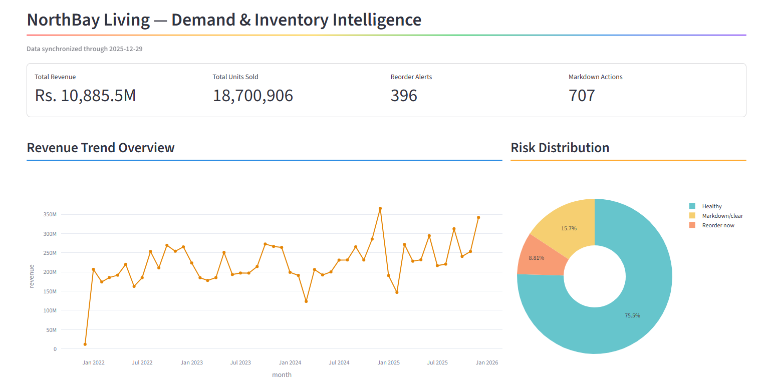
Fig 9.1 - Overview: company-wide revenue, units sold, reorder alerts, and risk distribution as of the latest data sync (through 2025-12-29).
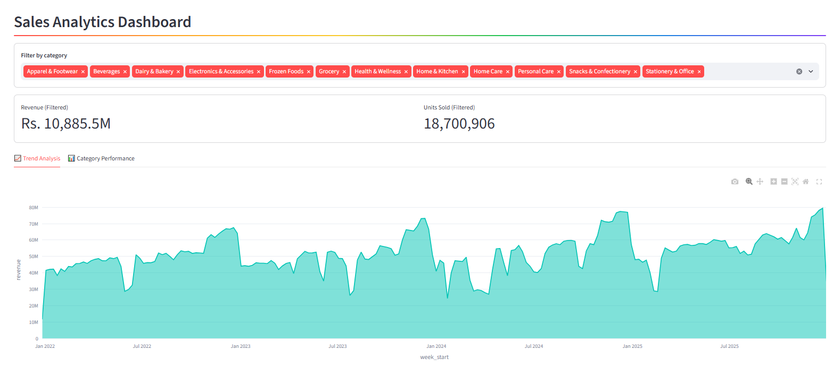
Fig 9.2 - Sales Analytics: revenue trend filterable across all 12 product categories.
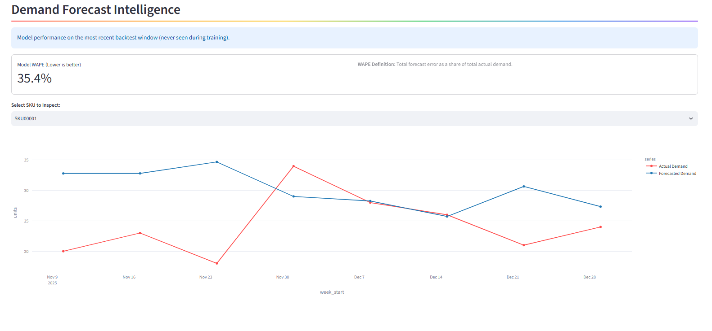
Fig 9.3 - Demand Forecast Intelligence: forecasted vs. actual demand for a selected SKU, with model WAPE on the latest unseen backtest window.
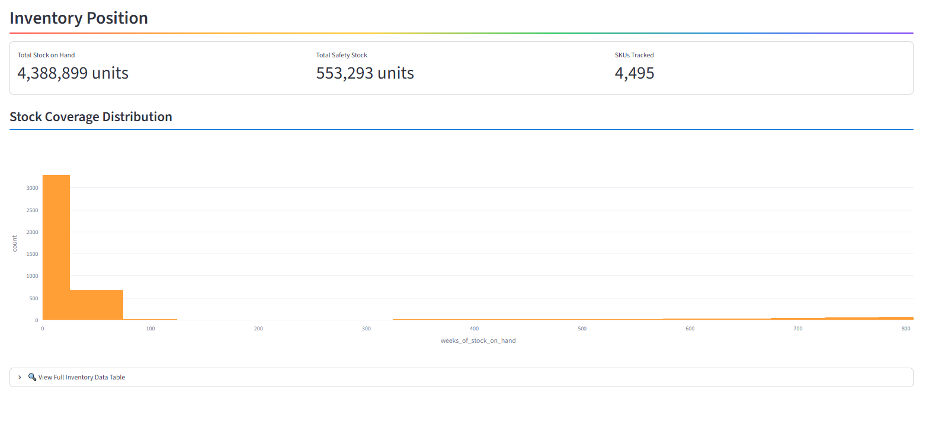
Fig 9.4 - Inventory Position: total stock on hand, total safety stock, and the stock-coverage (weeks-of-stock) distribution across all tracked SKUs.
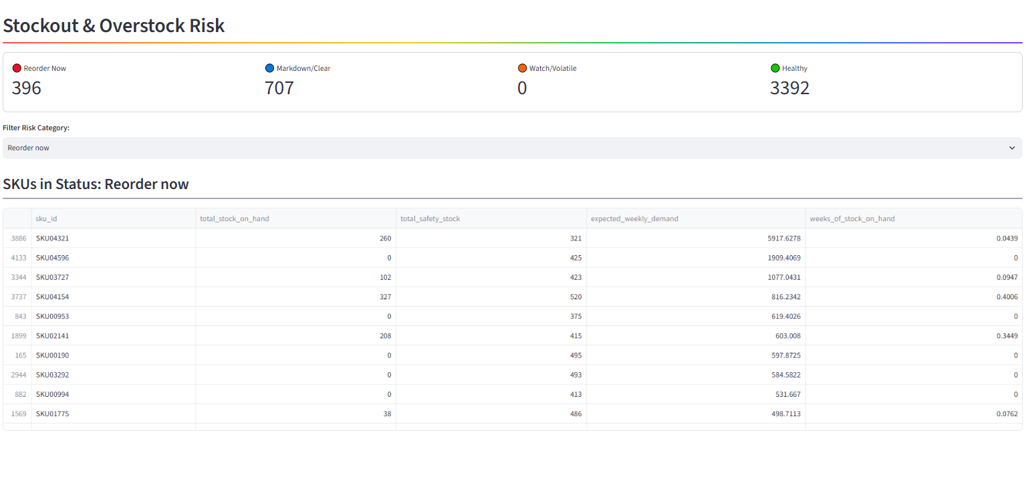
Fig 9.5 - Stockout & Overstock Risk: filterable risk categories with the underlying SKU-level action table.
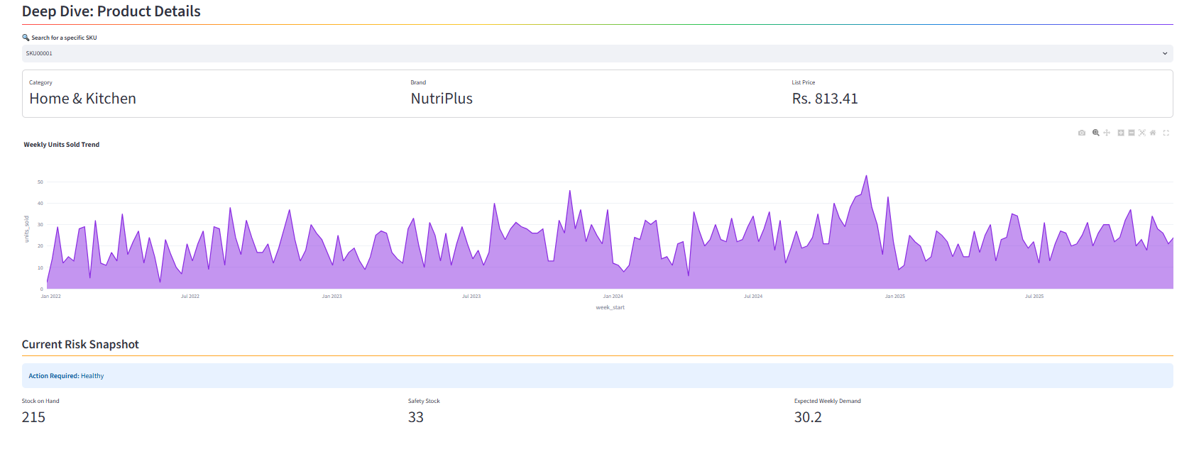
Fig 9.6 - Deep Dive: Product Details — per-SKU weekly units-sold trend alongside its current risk snapshot.
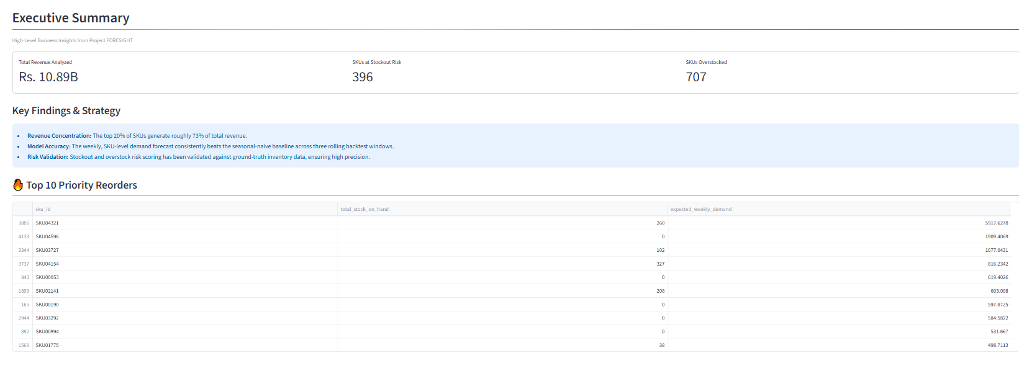
Fig 9.7 - Executive Summary: headline KPIs, key findings, and the top 10 priority reorders ranked by expected demand.

10. Technology Stack & Key Features

10.1 Key Features Delivered
ID | Feature | Description | Result
F1 | Data Quality Pipeline | Chunked profiling & cleaning of 9.95M-row dataset | 0 missing, 0 duplicate, 0 orphaned-key issues
F2 | Stockout Censoring Detection | Flags demand suppressed by injected stockouts | 55,327 (date, store, SKU) rows correctly flagged
F3 | Exploratory Analytics | Trend, seasonality, Pareto, promotion & category analysis | 6 validated, stakeholder-ready insights
F4 | Demand Forecasting | Weekly SKU-level forecast via LightGBM | Beats seasonal-naive baseline by 9.9%–24.7%
F5 | Risk Scoring Engine | Stockout & overstock classification per SKU | 95.5% / 100% recall vs. ground truth
F6 | Business Impact Quantification | Exact rupee value of both inventory problems | Rs. 32.3M lost, Rs. 799.2M locked
F7 | Interactive Web Dashboard | 7-page "NorthBay Living" dashboard for operations | Company-wide to SKU-level drill-down
F8 | Executive Reporting | Non-technical readout with recommended actions | 4 prioritised, ranked recommendations

10.2 Technology Stack
Category | Technology | Rationale
Programming | Python (Pandas, NumPy) | Primary language for data processing and analysis
Machine Learning | LightGBM, scikit-learn | Gradient-boosted forecasting; precision/recall evaluation
Data Storage | Parquet (PyArrow) | Efficient columnar storage for large intermediate tables
Environment | Google Colab, Google Drive | Cloud compute and persistent storage for a 10M-row dataset
Data Source | Kaggle API | Synthetic multi-store retail dataset acquisition
Visualization | Matplotlib | Exploratory analysis charts (trend, Pareto, category, promo lift)
Dashboard | Streamlit / Plotly | 7-page interactive web dashboard for business stakeholders
Version Control | Git & GitHub | Collaboration and code management

11. Recommended Actions
- 1. Protect SKU04321 specifically. A dedicated safety-stock policy is justified given it alone represents roughly a third of the company's entire stockout loss and close to a tenth of all revenue.
- 2. Act on the 396 SKUs flagged "Reorder now." Ranked by expected demand in the dashboard — the top of that list is where a stockout would hurt next.
- 3. Launch a clearance review of the 707 SKUs flagged "Markdown/clear." Recovering even a fraction of the Rs. 799.2M currently tied up frees real cash.
- 4. Re-run the pipeline and re-check risk thresholds periodically. Current thresholds were calibrated against a single point-in-time snapshot of known outcomes and should be expected to drift, not treated as permanently fixed.

12. Limitations, Stated Plainly
- The forecast model does not know the store's exact restock lead time or how much is already on order - that data wasn't available, so a documented assumption (roughly one week's lead time) stands in its place.
- Roughly half of flagged risk SKUs are false alarms at current settings - worth tightening further before this drives reordering decisions unattended.
- The risk-detection percentages were measured against this project's own known-answer dataset, not an independent, unseen test - real-world performance should be re-validated once live outcomes are available.
- The capital-locked figure values excess stock at cost price; it does not assume 100% of that value is recoverable through a markdown, since clearance sales typically recover less than full value.
- The Eid ul-Fitr and Eid ul-Adha holidays (lunar calendar) are not currently captured in the calendar's holiday flag - a known gap rather than an unnoticed one.
13. Challenges Faced & Solutions
Challenge | Solution
A 9.95M-row transaction file too large to load into memory at once | Streamed and aggregated the file in 1,000,000-row batches into revenue-weighted Parquet outputs
Two conflicting versions of the ground-truth flags file | Verified both directly against the raw 10M-row file; adopted the internally-consistent contaminated-folder version
Stockout windows silently look like zero customer demand | Explicit stockoutcensored flagging and exclusion from model training
A naive promo-lift test gave misleadingly weak results | Redesigned the test to compare each promo window against the period immediately preceding it, for the same targeted SKUs
A revenue-based overstock rule would miss the real slow movers | Re-derived overstock scoring on units sold vs. stock on hand, using the Week 2 percentile-rank finding
Naive risk-scoring thresholds gave very low precision | Grid-searched lead time, safety margin, and overstock threshold against the ground-truth flags to find a defensible, tuned setting

14. Key Learnings
- End-to-end ownership of a large, messy, real-world-scale dataset - from raw CSVs to a stakeholder-ready dashboard
- The discipline of verifying every claim against raw data rather than trusting documentation or a first-pass result
- Correct handling of censored / suppressed data in time-series modeling - a common but easy-to-miss trap in demand forecasting
- Walk-forward backtesting for time-series models, and why a random train/test split would have been misleading
- Translating model metrics (WAPE, precision, recall) into rupee-denominated business impact that a non-technical stakeholder can act on
- Building a dashboard that supports a decision workflow (Overview → Risk → Forecast → Recommendation), not just a set of unconnected charts

15. Future Roadmap
- Incorporate actual restock lead times and open purchase orders once available, replacing the current 1-week assumption
- Add the lunar Eid calendar to the holiday feature set
- Tighten risk-scoring precision further, particularly for the stockout flag, before allowing it to drive unattended reordering
- Re-validate risk-detection performance against live, post-deployment outcomes rather than only the project's synthetic ground truth
- Extend the forecasting model to a store-SKU grain for store-level replenishment, beyond the current chain-wide weekly SKU grain
16. Conclusion

Project FORESIGHT set out to answer a concrete business question - which products are about to run out, and which are quietly tying up cash - and answered it with numbers that trace back to verified calculations at every step, not assumptions. The data pipeline survived a 9.95-million-row dataset and two genuine data-quality issues without silently absorbing either. The forecasting model beat a meaningful baseline on data it never saw. The risk-scoring engine was validated, not just built, against a known-correct answer key. And the final output is not a static report but a live dashboard and a ranked action list that the business can use starting today.
The project also surfaces its own honest limitations - false-alarm rates, untested real-world assumptions, and known data gaps - rather than presenting a polished but overconfident picture. That combination of rigor and honesty is, we believe, the most valuable outcome of this internship.

Prepared by: Rishikesh Ojha, Swapnil Shirude, Ashika Keshri, Sreedhar Naidu
Zidio Data Science & Analytics Internship - Project FORESIGHT

